Packet Tracer - Configuring IPv4 and IPv6 Interfaces

1. Topology

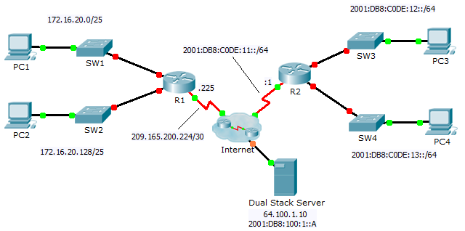

1. Addressing Table

|  |  |  |  |  |
| --- | --- | --- | --- | --- |
| Device | Interface | IPv4 Address | Subnet Mask | Default Gateway |
| IPv6 Address/Prefix | |
| R1 | G0/0 | 172.16.20.1 | 255.255.255.128 | N/A |
| G0/1 | 172.16.20.129 | 255.255.255.128 | N/A |
| S0/0/0 | 209.165.200.225 | 255.255.255.252 | N/A |
| PC1 | NIC | 172.16.20.10 | 255.255.255.128 | 172.16.20.1 |
| PC2 | NIC | 172.16.20.138 | 255.255.255.128 | 172.16.20.129 |
| R2 | G0/0 | 2001:DB8:C0DE:12::1/64 | | N/A |
| G0/1 | 2001:DB8:C0DE:13::1/64 | | N/A |
| S0/0/1 | 2001:DB8:C0DE:11::1/64 | | N/A |
| Link-local | FE80::2 | | N/A |
| PC3 | NIC | 2001:DB8:C0DE:12::A/64 | | FE80::2 |
| PC4 | NIC | 2001:DB8:C0DE:13::A/64 | | FE80::2 |

1. Objectives

Part 1: Configure IPv4 Addressing and Verify Connectivity

Part 2: Configure IPv6 Addressing and Verify Connectivity

1. Background

Routers R1 and R2 each have two LANs. Your task is to configure the appropriate addressing on each device and verify connectivity between the LANs.

**Note**: The user EXEC password is **cisco**. The privileged EXEC password is **class**.

1. Configure IPv4 Addressing and Verify Connectivity
   1. Assign IPv4 addresses to R1 and LAN devices.

Referring to the **Addressing Table**, configure IP addressing for **R1** LAN interfaces, **PC1** and **PC2**. The serial interface has already configured.

* 1. Verify connectivity.

**PC1** and **PC2** should be able to ping each other and the **Dual Stack Server**.

1. Configure IPv6 Addressing and Verify Connectivity
   1. Assign IPv6 addresses to R2 and LAN devices.

Referring to the **Addressing Table**, configure IP addressing for **R2 LAN interfaces**, **PC3** and **PC4**. The serial interface is already configured.

* 1. Verify connectivity.

**PC3** and **PC4** should be able to ping each other and the **Dual Stack Server**.